
ROUND B Template
Team Name (should be same as the one on the IC website):

 | Name | Imagine Cup  User Name | Email Address | Mobile Number | College
Team Member 1: | Amit Prakash Ambasta | Amit Prakash | amit.prakash.ambasta@gmail.com | 9444645629 | Chennai Mathematical Institute
Team Member 2: | Arpith Siromoney | arpith | arpith.siro@gmail.com | 9840382369 | Chennai Mathematical Institute
Team Member 3: | Hrishikesh Terdalkar | hrishikeshrt
Team Member 4: | Abhishek Chhajer
Mentor (if any):

* All team members and mentor (if any) must be registered on www.imaginecup.com

- What Problem are you trying to solve?
  - Your response should also indicate how this aligns with the Imagine Cup Theme. Ask yourselves whether it is really one of the toughest problems facing the world today.
  - Respond in less than 100 words.
We're interested in resource management, particularly in how it can be used to change lives. Several problems that technology can help solve, like sustainable development, urban planning, disaster management, and –especially-- agricultural management. All of the above problems are in-fact problems of resource allocation. More than tough problems facing the world today, we're keen that we solve tough problems in individuals' lives. Farmers in India for example can come up with suitable crop rotation patters which both meets their irrigation and seasonal constrains.

- What is your proposed Solution to the problem?
  - Respond in less than 100 words.
Our solution is an architecture designed to identify optimal patterns amongst resource allocation with given constraints. And this is where our project, the Development Optimization Engine, steps in. Our engine learns about the constraints, and comes up with smart ways to deal with them efficiently. The key, we feel, is the extendibility that naturally arises with our server client model. We've allowed to express constrains as plug-ins which act on the resources. Hence, simple plug-in development makes our engine applicable for a range of issues.

- Have any of you also created a team & signed-up for the optional Special Award categories? These are good opportunities for you to maximize your chances of winning.
Yes we have. We are registered for the Design for Development award, and we are planning to register for the Interoperability award (since our project architecture leads naturally to this). Finally, the ease of creating light weight clients helps us develop solutions which are accessible to a wider section of end-users. So we plan to register for the Accessibility award. We are driven by the goal of making changes in the world around us, changes that are felt by people with real problems, problems that underly the spirit of the UN millennium goals.
Special Award Category (optional)  Created a team & signed-up for this category on the IC website? (Yes/No)  Parallel Computing Award  Design for Development Award  MultiPoint Education Award  Interoperability Award  Accessibility Award |  | Yes  Yes  No  Yes  Yes

* It is not compulsory for Software Design category projects to also be submitted for any of the optional Special Award categories. However, if your project fulfills the criteria of any of these Special Award categories, you can consider submitting the same project for both the Software Design category as well as the appropriate Special Award category. Note that these Special Award categories have independent criteria and time-lines.

- Which Features of your software application have been implemented?
We develop with rapid prototyping, and hence have a working proof of concept implemented that allows for city planning based on proximity plug-ins for the constraints.

We have the elaborate back-end code to be employed in the final solution, written in C#. This part of the code implements the engine and a server and is fully functional. The engine allows for additional plug-ins while the server listens for a wide range of clients, from the traditional to the bleeding edge. Also the engine is responsible for the actual solution to the problem which it scores based on the plug-ins specified.

We've implemented the first plug-in Proximity, which is analogous to how during city planning, schools and markets desire close proximity with respect to residences while markets for example, tend to stay far from each other themselves. We'll be working on implementing more plug-ins once the end user clients are ready.

We've implemented a mediator for the end user client and the engine, which reads input from a XML file and feeds the same to the engine. Alternately it can be used as a library for a third party program. Its also responsible to deliver the output from the engine is a easy to read XML format. This allows an easy way for the end-user client (web client, desktop clients etc) to talk to the engine without having to implement a complicated protocol. This part of the code is fully functional as well.

We've got a rich web client, and are working on a client that uses an SMS server to interact with grass roots technologies. We're also working to enable the web client to talk to the mediator via read/write from/to XML output/input.

Finally, we're working on a full-feature desktop application that uses the Windows Presentation Foundation to enhance user interaction with the engine.

The key feature implemented is that we have enabled our engine to be highly extensible, leading to lowered barriers to fundamental optimization algorithms for the end-user. A plethora of plug-ins is planned to be added to actually simulate real life problems and their solutions, which due to the architecture are essentially easy to develop.

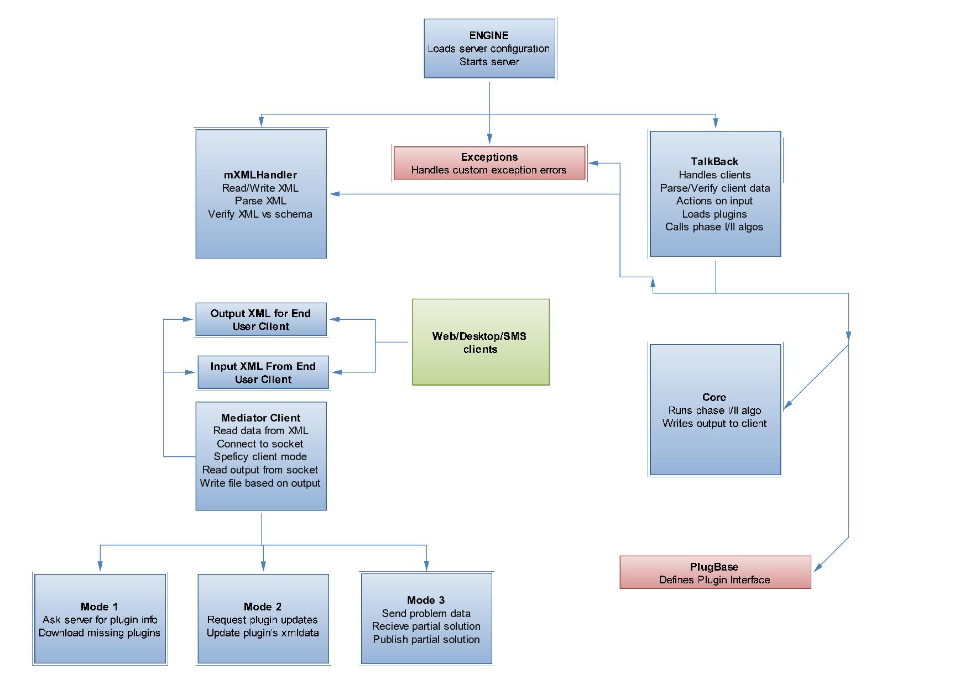
- Design Documentation
- Most of the functionality can be explained from the architectural diagram above.
- The actual desktop/web client sits on top of the mediator client from the server client model of the engine which does the required input format conversions to feed to the server and returns the output as formatted XML.
- A developer can write a set of plug-ins addressing one or more issues, which can be read by the engine and registered into the configuration file. We plan to add an array of plug-ins to address the same.
- The core algorithm for distribution of resources can be easily found on the supplied back-end engine which takes resources and plug-ins as input. A sample problem has been implemented via the proximity plug-in.
- The required elements are used to write the base server/client model from which everything else derives.
- Optional components will sit on top of the mediator client and talk using XML data. Specific plans are to include a SMS server and interoperability will be used to allow multiple clients [ mobile, desktop, web] etc to talk to each other. We also hope to deliver a parallel processing solutions for faster calculation of phase I/II algorithms.

